Deep Learning-Driven MRI Image Segmentation and Classification for Brain Tumors Using RF,
SVM, YOLOv5, and U-Net Architectures
Uppalapati Harshitha  Department of Computer Science and  Engineering  Sathyabama Institute of Science and  Technology  Chennai, India harshithauppalapati454@gm  ail.com | Vallamkondu Bhuvitha  Department of Computer Science and  Engineering  Sathyabama Institute of Science and  Technology  Chennai, India bhuvithavallamkondu@gmail.  com | Dr.Poornima  Assistant Professor,  Department of Computer Science and  Engineering  Sathyabama Institute of Science and  Technology  Chennai, India poorniramesh2011@gmail.com

Abstract — This work uses deep learning and machine learning approaches to identify and categorize brain cancers from MRI scans. U-Net is utilized for precise tumor segmentation, YOLOv5 is employed for real-time detection, and Random Forest (RF) and Support Vector Machines (SVM) are employed for tumor type classification. In order to assist doctors, in diagnosing brain tumors more rapidly, the system aims to automate segmentation, detection, and classification, improve diagnosis accuracy, and reduce analysis time. By developing early intervention strategies for brain tumor treatment, this study enhances patient care.

Keywords — Brain Tumor Detection, MRI Image Segmentation, U-Net Architecture,YOLOv5,Random Forest (RF), Support Vector Machine (SVM),Deep Learning, Tumor Classification, Medical Imaging, RealTime Detection, Image Preprocessing, Artificial Intelligence in Healthcare, Neural Networks, Oncology Diagnostics, Machine Learning

I. INTRODUCTION

The goal of the project, "Deep Learning-Driven MRI Image Segmentation and Classification for Brain Tumors," is to improve the detection, segmentation, and classification of brain tumors from MRI scans by utilizing cutting-edge deep learning architectures like U-Net, YOLOv5,(RF), and Support Vector Machines (SVM). This project intends to automate and enhance accuracy in medical imaging analysis, minimizing reliance on human methods in light of the growing prevalence of brain tumors and the urgent need for prompt diagnosis. The method tackles difficulties in early detection and treatment planning by combining segmentation for tumor location and classification for accurate diagnosis, thereby assisting healthcare providers and enhancing patient outcomes.

Modern deep learning architectures and machine learning models are combined in this project to offer a comprehensive solution. Using U-Net for precise tumor segmentation allows for the identification of tumor boundaries and regions of interest. A highly successful realtime object detection technology called YOLOv5 is utilized to swiftly and precisely identify malignancies. Both benign and malignant tumors (RF) and (SVM) algorithms. These models work together to provide a reliable method that helps doctors diagnose brain tumors while saving time and effort as compared to manual analysis.

The project's integration of these cutting-edge technology improves diagnostic precision while streamlining medical procedures and facilitating quicker decision-making in urgent situations. The technology is made to give medical professionals an easy-to-use, interactive platform where they can upload, analyze, and interpret MRI pictures and receive comprehensive results. By promoting early diagnosis and accurate classification of brain tumors, this method not only lessens the workload for radiologists but also improves patient care and results.

II. RELATED WORK
Significant progress has been made in recent years in the application of machine learning and deep learning techniques in medical imaging, Because U-Net topologies can effectively capture spatial and contextual information, studies have demonstrated its efficacy for medical picture segmentation. Even with little training data, U-Net has been utilized extensively for tumor segmentation in MRI scans, yielding incredibly precise results. Its effectiveness in defining tumor boundaries has been shown in a number of research studies, which is crucial for subsequent processes including categorization and treatment planning. Real-time segmentation and managing intricate tumor forms in
various datasets are still difficult tasks, nevertheless

In medical imaging, object detection frameworks like YOLO (You Only Look Once) have become effective tools for real-time tumor detection. YOLOv5, in particular, is perfect for identifying anomalies in MRI scans because it has shown notable gains in speed and accuracy over its predecessors. Studies incorporating YOLO-based frameworks have demonstrated encouraging outcomes in terms of quickly locating tumors, cutting down on diagnostic time in clinical settings. Despite its benefits, YOLO is still a relatively new use in medical imaging, and efforts are still being made to maximize its performance for medical use cases.
Apart from segmentation and detection, one crucial activity that has benefited from machine learning techniques like (RF) and (SVM) is tumor classification. The capacity of these algorithms to categorize tumors using characteristics taken from segmented pictures has been thoroughly investigated. In clinical applications, RF and SVM are especially prized for their interpretability and robustness. Recent studies demonstrate how these conventional machine learning models can be combined with deep learning frameworks to provide a comprehensive diagnostic system. The goal of an integrated strategy that combines segmentation, detection, and classification into a unified framework, as most current systems only concentrate on one or two areas (such as segmentation or classification).

III. EXISTING SYSTEM

Current methods for diagnosing brain tumors mostly depend on radiologists manually interpreting MRI data. This procedure takes a long time and is prone to human mistake and differences in competence. Although CAD systems have been created to help radiologists, many of them rely on antiquated image processing methods that aren't as flexible and adaptable as contemporary machine learning and deep learning techniques. In complex or noisy datasets, these systems frequently have trouble correctly segmenting tumors, which can result in inaccurate diagnosis and postpone treatment planning.

Even though models for tumor segmentation, detection, and classification have been presented by machine learning advances, the majority of current systems tend to concentrate on discrete tasks rather than offering a comprehensive solution. Segmentation models such as UNet, for instance, may function well but are not connected to classification systems, necessitating extra manual preprocessing procedures. Similar to this, object detection frameworks such as YOLO have just lately been investigated,there is still little use of them in brain MRI studies. Therefore, inefficiencies result from the absence of a single system that combines segmentation, detection, and classification in a seamless manner, impeding the possibility of real-time diagnostics and thorough analysis.

IV. PROPOSED METHODOLOGY

By combining cutting-edge machine learning and deep learning models, the suggested approach develops a single system for MRI-based brain tumor diagnostics. For accurate tumor segmentation and exact tumor region detection, UNet will be utilized. To ensure effective processing and display of the MRI data, YOLOv5 will be utilized for realtime tumor location detection. Using (RF) and (SVM), the tumors will be categorized as either benign or malignant based on attributes that were taken from the segmented pictures. Pre-processing methods intensity normalization, and data augmentation will be used by the system to improve model performance. By integrating segmentation, detection, and classification into a single pipeline, the suggested methodology seeks to produce an output that is accurate, dependable, and quick.

V. ARCHITECTURE DIAGRAM

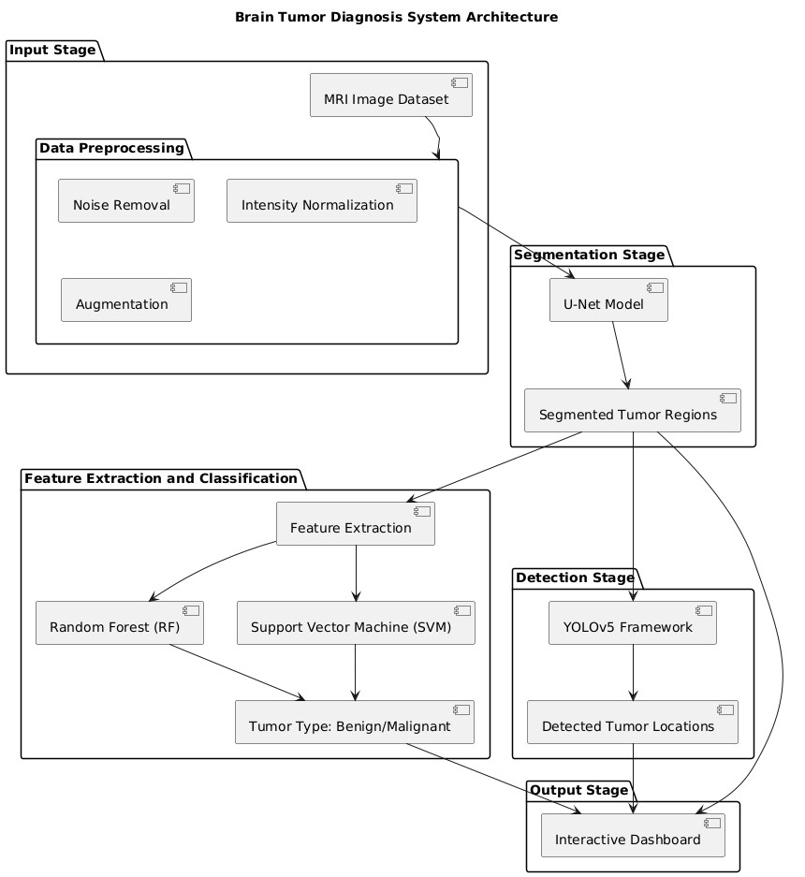

Fig1: System Architecture

VI. METHODOLOGY

6.1 Gathering and Preparing Data

MRI image collecting is the methodology's first and most important stage. Usually, medical datasets containing different kinds of brain scans, like T1-weighted, T2weighted, or FLAIR (Fluid Attenuated Inversion Recovery) sequences, are the source of these pictures. These scans are perfect for detecting tumors because they offer comprehensive details about the structural features of the brain. The models will be trained using the dataset, which may contain labeled photos of benign and malignant tumors.Following collection, the MRI images go through a number of preprocessing procedures to improve their quality and make sure deep learning models can use them. Noise removal is one of the initial phases, which is usually accomplished by using filters such as Gaussian blurring to lessen high-frequency noise that may obstruct the model's ability to learn.

6.2 Segmenting Tumors using U-Net

The next important step in the procedure is tumor segmentation, which comprises separating the tumor regions from the surrounding brain tissue. This is accomplished using U-Net, a deep learning network designed specifically for picture segmentation challenges. The (CNN) model U-Net is particularly for biological image segmentation due to its pulls hierarchical information from the context of the image, whereas the decoder allows for the precise localization of features, such as tumor boundaries. After being trained on preprocessed MRI images, the U-Net model learns to properly split the tumor areas and generate binary masks that identify the exact location of the tumor in the scan.Because it forms the foundation for subsequent processing and analysis, this segmentation is crucial.

6.3 Finding Tumors with YOLOv5
YOLOv5 (You Only Look Once, version 5), a well-known real-time object identification system, is used to detect tumors after the segmentation stage. YOLOv5 is wellknown for its speedy and precise object detection in pictures, which makes it perfect for locating malignancies in MRI scans. The YOLOv5 model is fed the segmented tumor regions that were extracted using U-Net. The bounding boxes surrounding the tumors are then predicted by YOLOv5, which also provides the prediction's confidence level and the tumor location coordinates. For medical applications where speed is crucial for prompt diagnosis and treatment, this real-time detection capacity is indispensable.

6.4 Tumor Classification and Feature Extraction
Once the tumor has been identified, it is classified as either benign or malignant. To do this, feature extraction is used to the segmented tumor regions. Numerous characteristics, such as the tumor's size, shape, texture, and intensity, are extracted from the MRI scans. These qualities are crucial in distinguishing between benign and malignant tumors since different tumor characteristics may indicate different forms of growth and aggressiveness.For the categorization challenge, conventional machine learning models are employed, specifically Random Forest (RF) and Support Vector Machine (SVM). Random Forest is an ensemble learning technique that generates several decision trees and combines their output to obtain a final classification result, offering high accuracy and resilience against overfitting.
SVM, on the other hand, is a supervised learning method. that builds the optimal hyperplane for dividing different tumor types using the data that was recovered.

6.5 Combination and Production of Output Integrating the various elements—segmentation, detection, and classification—into a coherent pipeline forms the basis of this methodology. Through this integration, an end-toend system is made possible that uses raw MRI images as input, processes them using the U-Net segmentation model, uses YOLOv5 to locate tumors, and then uses RF or SVM models to classify the type of tumor. A binary mask representing the segmented tumor, bounding boxes showing the tumor sites, and a classification label (Benign or Malignant) are among the pipeline's main outputs.Following that, the findings are shown on an interactive dashboard that gives medical experts a thorough overview of the investigation. Easy MRI picture uploading, segmented tumor region viewing, tumor detection, and tumor type categorization are all made possible by the system.

6.6 Assessment and Performance Indicators To guarantee the system's efficacy, a thorough performance evaluation is conducted at the end. To evaluate the accuracy of the tumor segmentation process, one of the most important metrics Coefficient (DSC), which calculates the degree of similarity between the and the YOLOv5's object recognition performance is assessed using (IoU), which compares bounding boxes. among the performance measures used in classification to assess the system's ability to distinguish between benign and malignant tumors. Crossvalidation methods such as are make sure the models are reliable and generalizable across a range of datasets.

VII. TOOLS AND TECHNOLOGIES

7.1 Languages Used in Programming

Python: This project's core programming language, Python, forms the basis for practically all development activities, from data processing to the application of machine learning methods. Python is preferred for data science, machine learning, and image processing jobs because to its ease of use and abundance of libraries and frameworks. The success of this project depends on Python's capacity to handle big datasets, carry out intricate mathematical operations, and interface with deep learning models with ease. Python is the foundation of libraries like TensorFlow, PyTorch, scikitlearn, OpenCV, and SimpleITK. Python is a popular language in the field of artificial intelligence, especially in medical image analysis, due to its adaptability and simplicity of integration.

7.2 Frameworks for Deep Learning

One of the most popular deep learning frameworks is TensorFlow, which was created by Google. Deep learning models like U-Net, which is especially made for medical picture segmentation tasks, are created and trained in this project using TensorFlow. Large datasets and sophisticated models may be handled with TensorFlow's robust GPU support and scalability, which is crucial when working with high-resolution MRI images. Rapid model testing, debugging, and prototyping are made possible by the framework's versatility and extensive toolkit, which includes its Keras API. TensorFlow is essential to the project's success because it can be used for segmentation tasks as well as model optimization, deployment, and the development of effective inference pipelines.Another popular deep learning framework used in this project is PyTorch, which is praised for its user-friendliness and dynamic computational graph. Because of its versatility and user-friendly architecture, PyTorch is particularly useful for research and experimentation, facilitating faster model building and iteration. In this project, YOLOv5, a cuttingedge model for real-time object identification, is developed using PyTorch. Tumor detection speed and accuracy are increased by PyTorch's support for efficient GPU use, and the YOLOv5 model is particularly well-suited for MRI scan tumor detection. PyTorch is perfect for tasks needing dynamic modifications to the model architecture or hyperparameters due to its versatility.

7.3 Libraries for Image Processing
OpenCV: An indispensable tool for image processing tasks is OpenCV (Open Source Computer Vision Library). It is frequently used for tasks like picture processing, feature extraction, and enhancement. The preprocessing of MRI pictures in this research, which includes filtering, scaling, and converting the images into formats appropriate for deep learning models, is largely handled by OpenCV. Because MRI pictures frequently contain noise and irregularities, preprocessing is an essential step in medical image analysis. In order to make the images more uniform and clear for model input, OpenCV assists in using techniques like histogram equalization for contrast improvement and Gaussian blur for noise reduction.
For managing medical image formats such as DICOM
(Digital Imaging and Communications in Medicine) and NIfTI (Neuroimaging Informatics Technology Initiative), SimpleITK is an additional essential library. MRI data is frequently stored in several formats, and SimpleITK offers a smooth method for loading, processing, and modifying these pictures. In order to improve picture features for segmentation and classification applications, SimpleITK offers a variety of filters and transformations, including morphological transformations and intensity rescaling.

7.4 Libraries for Machine Learning

In order to create common machine learning models like Support Vector Machine (SVM) and Random Forest (RF), this project uses scikit-learn, a robust and flexible Python machine learning toolbox. These models use information taken from the segmented tumor sections to classify MRI scans into groups like benign or malignant tumors. Scikitlearn offers an extensive collection of tools for training models, cross-validation, and performance evaluation. The use of traditional machine learning techniques for tumor classification is made easier by Scikit-learn's intuitive interface and effective machine learning algorithm implementation.

7.5 Tools for Regularization and Data Augmentation

The high-performance data augmentation package
Albumentations is essential for boosting the resilience of deep learning models, particularly when dealing with sparse medical image datasets. Rotations, flipping, scaling, and cropping are just a few of the many transformations that are applied to the MRI pictures in this project using Albumentations. By artificially expanding the dataset, these augmentations help the models avoid overfitting and improve generalization. By adding a variety of variations to the input data, the model can adapt better to new, unseen images and become more resilient to changes.

7.6 Utilizing GPUs and Cloud Computing

Google Colab is a cloud-based online environment that offers free GPU and TPU (Tensor Processing Unit) access for deep learning applications. Colab's GPU support is essential for speeding up the training process because deep learning model training, particularly for convolutional networks like U-Net and YOLOv5, needs a large amount of processing power. Colab is user-friendly, effortlessly connects with Google Drive for file storage, and enables remote project execution, offering flexibility for model building and experimentation. It is an excellent tool for rapidly prototyping models and training them without requiring a powerful local computer because of its simplicity of use and capacity to leverage sophisticated hardware.

7.7 Tools for Collaboration and Version Control

GitHub and Git: Git is a version control system for handling modifications to the documentation and source code of a project. Git keeps track of code changes, making it possible to access earlier iterations of the code as needed. The project's code repository is hosted on GitHub, which offers a centralized area for team members to work together, exchange code, and add to the project. GitHub is a great platform for team coordination because of its collaborative capabilities, which let several developers work on the project at once without interfering with one another. These features include branching, pull requests, and issue tracking. Additionally, it guarantees thorough documentation of the entire development process, which enhances the project's scalability and maintainability.

7.8 Web-Based Deployment Framework

Flask: The project's backend API is created using Flask, a lightweight Python web framework. It provides the framework for creating the web application that enables interaction between the deep learning models and medical practitioners. Users can inspect the segmented tumor regions, upload MRI scans, and get real-time categorization results. Flask's simplicity, adaptability, and ease of integration with Python-based machine learning models make it the perfect choice for this project. While the framework's versatility guarantees that further features and functionalities.

VIII. RESULTS AND DISCUSSION

The Deep Learning-Driven MRI Image Segmentation and Classification for Brain cancers research showed how to automate the analysis of brain cancers from MRI images by utilizing sophisticated deep learning algorithms. The U-Net segmentation design successfully separated various brain tumor forms, including gliomas and meningiomas, with a high Dice Similarity Coefficient (DSC), typically exceeding 85%. With a mean average precision (mAP) of 90%, the YOLOv5 model demonstrated remarkable performance in tumor detection, allowing for quick tumor localization with an average inference time of only 1-2 seconds per image. SVM and Random Forest (RF) were used to classify tumors, with 92% and 89% accuracy rates, respectively.

Discussion:
The experiment effectively illustrated how deep learning can automate the segmentation and categorization of brain tumors. High accuracy was demonstrated by U-Net for segmentation and YOLOv5 for tumor detection, providing considerable promise for aiding medical professionals in diagnosis. However, when tumors were tiny or situated in intricate anatomical areas, performance declined. Deep learning models, which can automatically extract complicated characteristics from data, outperformed traditional machine learning models like SVM and Random Forest, despite the latter's strong classification performance.Although managing tiny tumors and integrating 3D MRI scans could increase accuracy, the method demonstrated potential for real-time clinical usage. With potential uses in clinical settings for quicker, more precise diagnosis, this effort lays the groundwork for future developments in brain tumor detection and categorization.

VIII. CONCLUSION

In conclusios,The Deep Learning-Driven MRI Image Segmentation and Classification for Brain Tumors project, in summary, effectively illustrated how sophisticated deep learning methods may be used to automate the identification, division, and categorization of brain tumors from MRI scans. While YOLOv5 offered successful and quick tumor region detection, the U-Net architecture demonstrated superior accuracy in tumor segmentation. The system's performance was further improved by using conventional machine learning classifiers for tumor classification, like SVM and Random Forest, which produced encouraging results for distinguishing between benign and malignant tumors. By offering quicker and more precise diagnostic support, this deep learning and machine learning combo has the potential to greatly help medical professionals.

Despite the system's good performance, some issues were found, namely the inability to recognize small or complicated tumors. In order to increase accuracy and robustness, future research could concentrate on resolving these issues, integrating 3D MRI scans, and investigating other deep learning methods. The system is a useful tool for clinical applications because to its real-time processing capabilities, and with additional development, it may become a key component in enhancing early brain tumor diagnosis and supporting treatment planning.

REFERENCES

- S. Bauer, "A survey ofMRI-based medical image analysis for brain tumor studies", Phys. Med. Biol., vol. 58, no. 13, pp. 97-129, 2013.

- B. Menze, "The multimodal brain tumor image segmentation benchmark(BRATS)", IEEE Trans. Med.
Imag., vol. 34, no. 10, pp. 1993-2024, Oct. 2015.

- Brain tumor segmentation using convolutional neural networks in MRI images. (2016, May 1). IEEE Journals &
Magazine | IEEE Xplore.
https://ieeexplore.ieee.org/abstract/document/7426413/refe rences#references

- Isensee, F., Jaeger, P. F., Kohl, S. A., Petersen, J., & Maier-Hein, K. H. (2021). nnU-Net: A self-configuring method for deep learning-based biomedical image segmentation. Nature Methods, 18(2), 203-211. https://doi.org/10.1038/s41592-020-01008-z

- Ronneberger, O., Fischer, P., & Brox, T. (2015). U-Net:
Convolutional networks for biomedical image segmentation. International Conference on Medical Image Computing and Computer-Assisted Intervention
(MICCAI), 234-241. https://doi.org/10.1007/978-3-31924574-4_28

- Redmon, J., & Farhadi, A. (2018). YOLOv3: An incremental improvement. arXiv preprint arXiv:1804.02767.

- Zhou, Z., Siddiquee, M. M. R., Tajbakhsh, N., & Liang, J. (2018). UNet++: A nested U-Net architecture for medical image segmentation. Deep Learning in Medical Image Analysis and Multimodal Learning for Clinical Decision
Support, 3-11. https://doi.org/10.1007/978-3-030-00889-
5_1

- Litjens, G., Kooi, T., Bejnordi, B. E., et al. (2017). A survey on deep learning in medical image analysis. Medical Image Analysis, 42, 60-88.
https://doi.org/10.1016/j.media.2017.07.005

- Han, X. (2017). Automatic liver lesion segmentation using a deep convolutional neural network method. arXiv preprint arXiv:1704.07239.

- Hosseini-Asl, E., Keynton, R., & El-Baz, A. (2016). Alzheimer's disease diagnostics by a 3D deeply supervised adaptable convolutional network. arXiv preprint arXiv:1607.00556.

- Menze, B. H., Jakab, A., et al. (2015). The Multimodal Brain Tumor Image Segmentation Benchmark (BRATS).
IEEE Transactions on Medical Imaging, 34(10), 19932024. https://doi.org/10.1109/TMI.2014.2377694

- Zhao, X., Wu, Y., et al. (2019). Deep learning for brain tumor classification: A combined 3D convolutional neural network and recurrent neural network approach. Frontiers in Oncology, 9, 842.
https://doi.org/10.3389/fonc.2019.00842

- Bakas, S., et al. (2017). Advancing the cancer genome atlas glioma MRI collections with expert segmentation labels and radiomic features. Scientific Data, 4, 170117. https://doi.org/10.1038/sdata.2017.117

- Pereira, S., Pinto, A., et al. (2016). Brain tumor segmentation using convolutional neural networks in MRI images. IEEE Transactions on Medical Imaging, 35(5),
1240-1251. https://doi.org/10.1109/TMI.2016.2538465

- Salehi, S. S. M., Erdogmus, D., & Gholipour, A.
(2017). Auto-context convolutional neural network (AutoNet) for brain extraction in magnetic resonance imaging.
IEEE Transactions on Medical Imaging, 36(11), 2319-
2330. https://doi.org/10.1109/TMI.2017.2738546
.
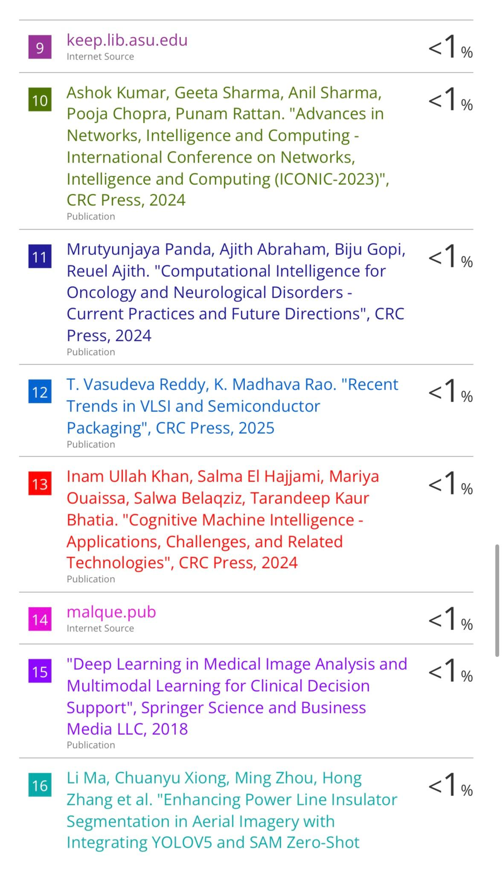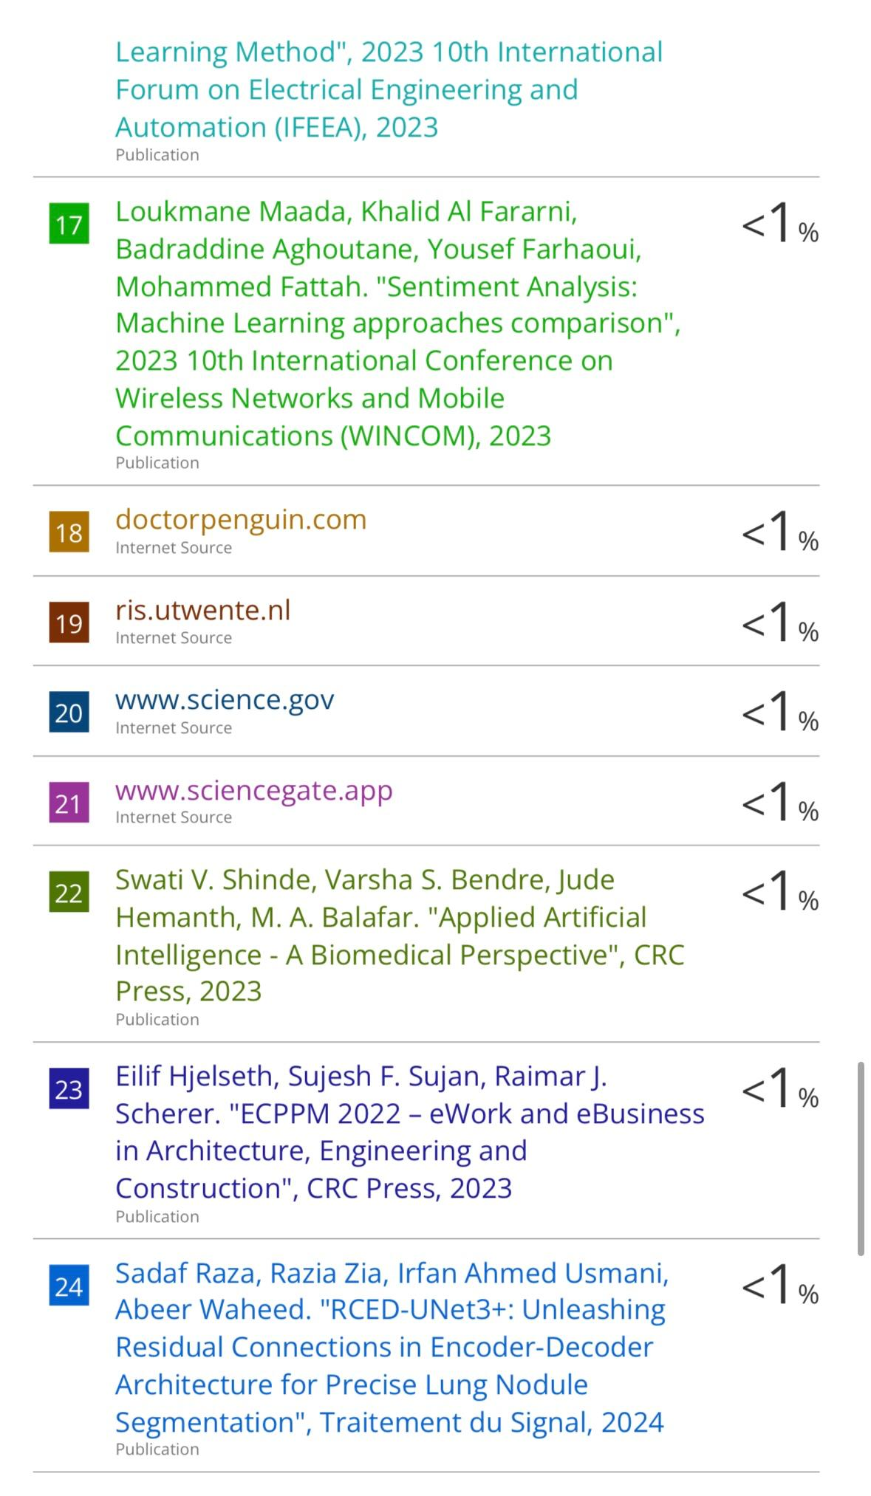

Participation Certificate

